Amplifier Heating Model

The model for the amplifier heating is:

T_amp(k) = R_eff * I(k-1) * deltaT + (1 – heatTransferRate) * T_amp(k-1) (1)

Where:
T_amp(k) Amplifier temperature at time k
R_eff Effective resistance of the amplifier. This controls the rate at which the amplifier heats [0.065]
I(k) Actual current sent to the motor at time k. Also called motorCurrent in the simulation below.
deltaT Time step [0.001 s]
heatTransferRate Rate at which the amplifier transfers heat out, or cools [0.00008]

I_avail Current available from the amplifier based on the amplifier temperature.
I_peak Peak current that the amplifier can source [30 A]
I_cont Current level that the amplifier can source indefinitely [15 A]
T_amp_max Maximum allowable amplifier temperature before current is clipped to continuous level. [150]
I_request Requested current from the controller.

To calculate the I_avail:
Update T_amp according to equation (1).
If (T_amp < T_amp_max)
I_avail = I_peak
Else
I_avail = I_ cont

To determine the current send from the amplifier:
If ( | I_request| < I_avail)
I(k) = I_request
Else
I(k) = I_avail * signum( I_request)

Here is a simulation of the amplifier temperature response:
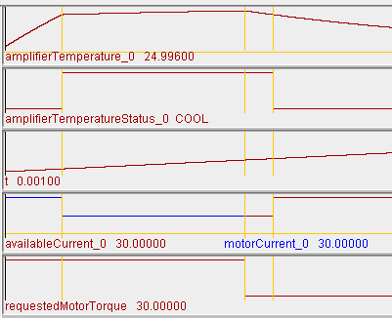
At t=0
I_request = 30A
T_amp = 25 (nominal temperature)
I_avail = 30A
motorCurrent = 30A

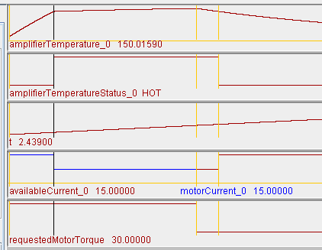
Amplifier heats up and output current is clipped to continuous level:
At t=2.439
T_amp = 150
I_request = 30A
I_avail = 15A
motorCurrent = 15A

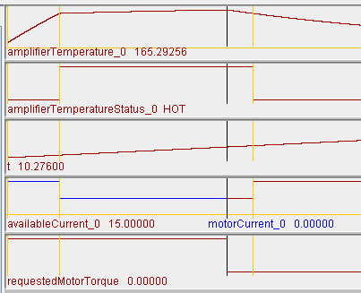

Amplifier reaches close to steady state temperature. Requested current is now set to zero which allows the amp to cool.
At t= 10.28s
T_amp = 165
I_request = 0A
I_avail = 15A
motorCurrent = 0A

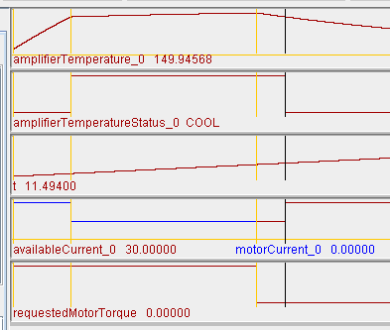
After about 1.25s amplifier cools to just below maximum allowable temperature and available current is now the peak. However, any current draw at this point will heat the amp above the maximum allowable.
At t= 11.5s
T_amp = 150
I_request = 0A
I_avail = 30A
motorCurrent = 0A

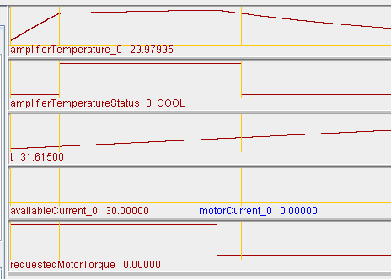
After about 20 seconds of cooling, the amplifier has reached nominal temperature
At t= 31.6s
T_amp = 30
I_request = 0A
I_avail = 30A
motorCurrent = 0A

